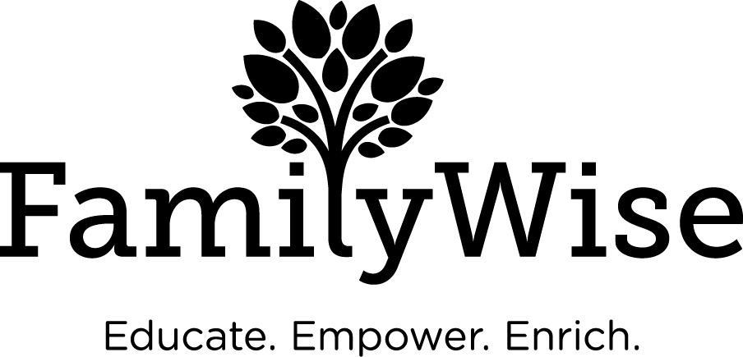

Date of Referral

Parent Information
Name
Address
County
Phone Number(s)
Email
Birth Date
Gender
Ethnicity
Languages Spoken

Other Children/Family Members
Name | Date of Birth | Gender | Ethnicity

Reason for Referral
Please include background information, desired outcome of service and attach supporting documentation as necessary. Call 612.877.7819 with questions.

Involvement with County and/or Other Systems (check as many as apply)
Please attach supporting documentation as appropriate.
Criminal Justice
Family Court
Child Protection Services (CPS)
Chemical Dependency Program
Assistance Program through State
Other

Other Contact (attach Release of Information form if applicable)
Name
Agency
Address
Phone Number(s)
Email

Payment Information
Pre-paid virtual 1-hour intake session & handbook signatures required to continue to additional sessions.

To pay go to: https://familywiseservices.org/11-parent-coaching/
$20 virtual 1-hour intake session
$40 per hour session - Services are virtual and one to one.
$100 per hour session- Services are community/home-based and in person. In order for children to attend in-person services, prior approval from the program Supervisor is required.
$20.00 per hour for any documentation review or letter writing for court.

Payment is due before each session.
You can pay for one session at a time or for multiple sessions at a time.
Refunds for pre-paid, un-used sessions can be requested up to one year from the date of payment.
When it asks for dates of sessions, write in “1:1 Parent Coaching.”

Once you’ve made a payment online, please take a screenshot and email it to your assigned Family Specialist. This will function as your proof of payment/receipt.

Please call 612.877.7819 for further questions.

