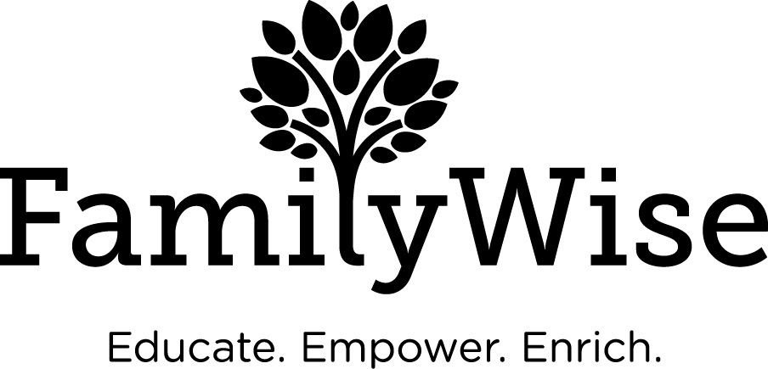

Date of Referral

Parent Information
Name
Address
County
Phone Number(s)
Email
Birth Date
Gender
Ethnicity
Languages Spoken

Payment Information
To pay go to: https://familywiseservices.org/programs-services/parent-education-support/parent-education-groups/
$20.00 per hour session – Currently are only providing One-On-One Parent Education due to COVID via Zoom
Payment is due before session
When paying online, you can pay for one session at a time or in multiple (Just write in quantity of sessions you are wishing to pay).
When it asks for dates of sessions, write in One-On-One.
Please call 612.877.7830 for further questions

Other Children/Family Members
Name | Date of Birth | Gender | Ethnicity

Reason for Referral
Please include background information, desired outcome of service and attach supporting documentation as necessary. Call 612.877.7830 with questions.

