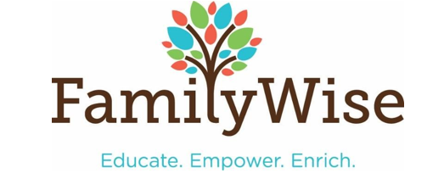SUPERVISED EXCHANGE
Parent Registration
COST: $20.00 per one-way exchange; Beginning and Return cost is $40.00
Exchanges are managed at 3036 University Ave SE, Minneapolis MN 55414 and are considered car-to-car exchanges
Days, Dates and Times: Mondays 9:30am to 6pm, Tuesdays 4pm-7pm, Wednesdays 9:30am to 6pm, Fridays, 9:30am to 430pm and Saturdays 9am to 4pm
Once completed please fax: 612-617-0193 or e-mail: intake@familywiseservices.org
Include a copy of your picture ID
Include current court order
Only the person named in the court order may pick up and drop off
Each parent will be assigned a parking lot in which to wait and the person receiving the child should be the first to leave the parking lot
Number of children involved in the exchange:
The fees for the exchanges must be paid using the secure online service below and must be paid within 24 hours of the service
- Go to website: https://familywiseservices.org/programs-services/supervised-parenting-services/
- Click on the blue button at the top of the page ‘Pay for Supervised Parenting or Safe Exchange Services’
- Fill in the form. All fields are required.
Click Pay. A receipt will be sent to the email address you entered in the form
- Parent Name: DOB:

Address: City State Zip

Phone: E-Mail: Car/Color/Make /Model

- Parent Name: DOB:

Address: City State Zip
Phone: E-Mail: Car/Color/Make/Model

